Internal validation in OASIS model for skin sensitization

The following is a description of the process of internal validation in OASIS model for skin sensitization. For the purposes of internal validation, the model is assumed to provide binary predictions (positive/negative). As the original data and predictions are in more informative scale (strong sensitizer/week sensitizer/very week sensitizer/non sensitizer), the following conversion is used:
- Strong sensitizer/week sensitizer -> positive
- Very week sensitizer/non sensitizer -> negative.

Internal validation
Once a model is derived its predictive performance is measured by the goodness-of-fit (GOF), i.e. how well the model fits its observed data. However, it is known that this measure is optimistic and is higher than the predictive performance over any other data different from the training set. If an external (test) data is available than an external validation could be done and the performance over the test set could be compared to the goodness-of-fit.
If no external data is available a statistical procedure called internal validation could be executed in order to assess how well the model would predict external data. During this procedure the original training set is separated many times randomly into two parts – one becomes a training set and the other becomes a test set. A new model is derived for each new training set and the new model’s performance over the both training and test sets is registered. The averaged value of all training set performances is compared to the averaged value of all test set performances in order to assess the amount of optimism in the goodness-of-fit (GOF optimism, or overfitting) in the original model.

Selecting the training and test samples
Different procedures exist for selecting the training and test samples. Each of them has its pros and cons, so here we will use two acknowledged methods – cross-validation and bootstrapping.
In k-fold cross-validation the original training set is partitioned into k equally sized subsets. Each time a single subset is used as a test set and the remaining k-1 subsets are used as training set. In this manner the process is repeated k times and each data from the original training set is used once as a test data and k-1 times as a training data. The advantage of this method is that any data is used for both training and validation and each data is used exactly once as a test data. Commonly the 10-fold cross-validation is used (90% training data, 10% test data), but we will use also 4-fold cross validation (75% training data, 25% test data).
In Monte Carlo cross-validation the original training set is split randomly into training and test set. The process can be repeated many times. The advantage of this method (compared to k-fold cross validation) is that the proportion between training and test sets does not depend on the number of repetitions in the internal validation procedure.
In bootstrapping the new training sets is populated from the original training set by random sampling with replacement until the size of the new training set reaches the size of the original training set. The data not selected for the new training set becomes the new test set. On average, about 63% of original training set data goes into the new training set (some of the data appear more than once) and 37% remains in the new test set. The process can be repeated many times. One of the advantages of this method is the fact that the new training sets and the original training set are equally sized.
Monte Carlo cross-validation and bootstrapping suppose creating a large number of new training/test sets (1,000 – 10,000).

Alerts in OASIS model for skin sensitization
OASIS model for skin sensitization produce predictions based on alerts. Alert is a structural fragment which, if found in predicted chemical or in some of its metabolites, serves as an indicator for presence of effect (the predicted chemical is “positive” – i.e. it causes the effect predicted by the model). The different alerts act independently, which means that one chemical could be predicted positive by more than one alert. The purpose of any alert is to select only positive chemicals among the population. It is not expected one alert to select all positive chemicals, but it is desired all chemicals selected by an alert to be positive.
The usefulness (performance) of an alert is measured by the proportion of positive chemicals within all chemicals selected by the alert. The alert performance has a meaning of a probability and is fitted by a beta distribution. An alert could be considered useful if its performance is statistically higher than the proportion of positive chemicals within the whole training set.

Assessing the performance of alerts
Each alert can be tested against the data from training set and its performance can be compared with the performance of a naïve alert.
A naïve alert is an alert which has no ability to select positive chemicals, i.e. its performance is equal to the proportion of positive chemicals in the training set.
The alert performance is assessed by the proportion of positive chemicals within all chemicals selected by the alert. As the real performance is not known, we can describe it via its probability distribution which is a special statistical function – beta distribution. The performance estimation is equal to the expectation of the beta distribution inferred from the pair [correct; incorrect] applications of the alert.
NOTE:
In all following explanations alert performance will stand for alert performance estimation calculated from the sample [correct; incorrect] applications.

Although the alert performance shows what is the accuracy of the alert in selecting positive chemicals, this estimation lacks some important information – what is the proportion of positive chemicals in the population over which the alerts works. Indeed, it is much easier to select 5 out of 5 from a population with 70% positive chemicals than to select 5 out of 5 from a population with 30% positive chemicals. A measure that includes the latter is called p-value. The p-value is the probability a performance equal or better than the performance of the alert to be achieved by chance if drawing chemicals randomly from training set. In this manner the p-value can serve as a measure for the reliability of alert performance estimation. The lower p-value means higher reliability and if the p-value cannot complement the confidence level to 1 it shows that the alert performance is statistically confirmed at the used confidence level. For example, if the confidence level is 95%, the p-value must be smaller than 5% in order alert performance estimation to be confirmed¹⁾.
Depending on their performance alerts can be classified as follows:
- confirmed – when their performance is significantly higher¹⁾ than the performance of a naïve alert,
- disproved – when their performance is significantly lower¹⁾ that the performance of a naïve alert,
- undecided - when their performance cannot be distinguished statistically¹⁾ from the performance of a naïve alert,
- theoretical - when they have no application over the training set.
¹) The default confidence level used in the analysis is 95%.

NOTE:
If an alert is classified as undecided, it doesn’t mean that it would have weak performance. Such classification may also appear if the number of chemicals selected by the alert is small (i.e. due to data insufficiency).
In both cases – small count of selected chemicals or performance closer to the performance of a naïve alert, – the p-value is higher than 5%.

Examples of alert performances and their classification:
Example #1 – 12 correct, 1 incorrect application(s) (p-value = 0.0002)
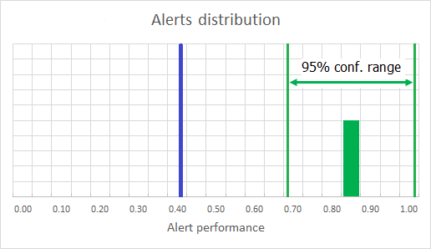
Fig. 1 - The blue line represents the performance of a naïve alert; the green alert [12; 1] has a better performance and its confidence does not include the performance of a naïve alert

Example #2 – 1 correct, 0 incorrect application(s) (p-value = 0.420)
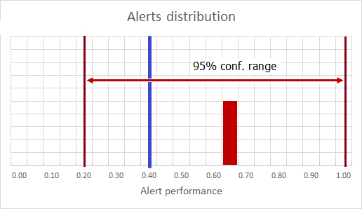
Fig. 2 - The blue line represents the performance of a naïve alert; the brown alert [1; 0] has a better performance, but it is NOT confirmed due to data insufficiency (its confidence range is too wide and includes the performance of a naïve alert)

Example #3 – 19 correct, 18 incorrect applications (p-value = 0.162)
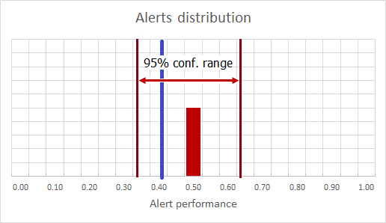
Fig. 3 - The blue line represents the performance of a naïve alert; the brown alert [19; 18] has a narrower confidence range, but it is NOT confirmed because its performance is close to the performance of a naïve alert

Deriving OASIS model for skin sensitization
Each OASIS model starts with an initial library of alerts. These alerts are defined by experts and embrace existing knowledge. For any available training set these alerts could be tested against the data and their performance assessed and recorded. But along with individual alerts performances, we would be also interested in the joint performance of all alerts participating in the model.
One possible solution would be our newly derived model to use only confirmed alerts. But having in mind that many of available alerts could remain undecided due to small count of applications we prefer to do the opposite – to use all alerts (no matter confirmed or undecided) which have at least one application in the training set.
A problem could arise here if we use more alerts than needed and thus select too many chemicals (and predict them as positive). To identify such situation, we could compare the individual performances of positive and negative predictions and if the performance of positive predictions is poorer that the performance of negative predictions it would serve as an indication that the alerts used in the model are more than actually needed.
Estimation of model performances:
The performance of a model is measured in the same way as the performance of an alert – by the mean value of the beta distribution corresponding to the pair [correct; incorrect] applications. The reliability of the performance estimation is measured by the p-value for having such or better performance if drawing randomly correct+incorrect chemicals from the training set.

IMPORTANT NOTE:
When we talk about the performance of positive and negative predictions we have in mind the probabilities for correct predictions achieved when the model is applied on its training set. As these probabilities depend on the proportion between positive and negative chemicals in the set we try to assess, the performance values may become misleading and should be recalculated.
Measures that do not depend on the proportion positive/negative chemicals are the performances of the model over positive chemicals (sensitivity) and negative chemicals (specificity). We provide the latter as means for calculating the performances for positive and negative predictions if the initial proportion between positive and negative chemicals is known.

Estimation of GOF optimism:
Comparing the averaged estimations of any kind of performance (predictions performance, sensitivity, specificity) over training and test sets respectively, gives the ability to calculate the GOF optimism in this estimation and consequently to subtract it from the estimation obtained from the whole training set. Thus the corrected value is expected to be true for an external set over which our model is applied.
Given the fact that we make several types of internal validation sampling, we can average the GOF optimism values from any type of sampling and thus obtain a more reliable result.
For example, when assessing the GOF optimism (GO) for sensitivity, we can use the formula:
$${GO}_{ avg.}=\frac{{GO}_{ kfold x4}+{GO}_{ kfold x10}+{GO}_{ MC 63\%}+{GO}_{ MC 75\%}+{GO}_{ bootstr.}}{5}$$

and then to calculate the sensitivity of our model over external sets:
$${Sensitivity}_{ ext.}= {Sensitivity}_{ train.}- {GO}_{ avg.}$$

The technique described above relies on results from internal validation and must not be confused with external validation!!
The formulas for calculating the above measures are given below:
$${Performance}_{ est.}=\frac{T+1}{T+F+2}$$
where
T – count of correct applications/predictions of alert/model
F – count of incorrect applications/predictions of alert/model

$$p value=\sum_{i=0}^{F}{\left(\frac{A!}{(T+i)!(F-i)!} * \frac{(A'+1)!}{T'!F'!} * \frac{\left(T+i+T'\right)!\left(F-i+F'\right)!}{(A+A'+1)!}\right)}$$
where
T – count of correct applications/predictions of alert/model
F – count of incorrect applications/predictions of alert/model
A – count of all applications/predictions of alert/model, A = T + F
T’ – count of correct applications/predictions in the whole training set
F’ – count of incorrect applications/predictions in the whole training set
A’ – count of all applications/predictions in the whole training set, A’ = T’ + F’

Training set performances:
$${Sensitivity}_{ est.}, (performance over positive chemicals)=\frac{TP+1}{TP+FN+2}$$
$${Specificity}_{ est.}, (performance over negative chemicals)=\frac{TN+1}{TN+FP+2}$$
$${Performance}_{ est.}, all predictions=\frac{TP+TN+1}{TP+FP+TN+FN+2}$$
$${Performance}_{ est.}, positive predictions=\frac{TP+1}{TP+FP+2}$$
$${Performance}_{ est.}, negative predictions=\frac{TN+1}{TN+FN+2}$$
where
TP (true positives) – count of correct positive predictions
FP (false positives) – count of incorrect positive predictions
TN (true negatives) – count of correct negative predictions
FN (false negatives) – count of incorrect negative predictions

Recalculated performances over external sets:
$${Performance}_{ ext.}, all predictions= π*SE+\left(1-π\right)*SP$$
$${Performance}_{ ext.}, positive predictions=\frac{π*SE}{π*SE+\left(1-π\right)*(1-SP)}$$
$${Performance}_{ ext.}, negative predictions=\frac{\left(1-π\right)*SP}{\left(1-π\right)*SP+π*(1-SE)}$$
where
$π$ – proportion of positive chemicals in the external set
SE – sensitivity (performance of model over positive chemicals)
SP – specificity (performance of model over negative chemicals)

Results from model “Skin sensitization”

Alerts library
The model contains 112 alerts defined by experts.

Available data
The training set of the model contains 1406 chemicals, including 566 positive and 840 negative. 39 training chemicals are private and cannot be seen in the training set distributed with TIMES installation. The performance of a naïve alert is 0.403 (0.377 ÷ 0.428)¹⁾.
¹) Confidence range is calculated at 95% confidence level

Alerts performance
The alerts performance over the whole training set is as follows:
Classification | Count
Confirmed | 27
Disproved | 0
Undecided | 45
Theoretical | 40¹⁾
¹) 40 alerts have no application in the training set

The distribution of alerts performance over the whole training set is as follows:
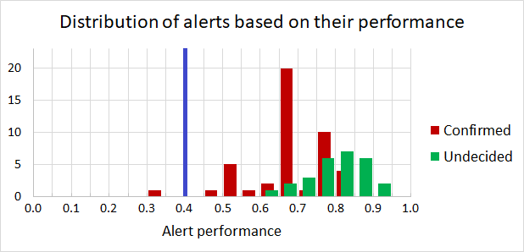
The blue line represents the performance of a naïve alert

Undecided alerts
The distribution of undecided alerts is as follows:
Count of applications | Count of alerts
>= 10 | 2
5 - 7 | 3
3 - 4 | 8¹⁾
2 | 14²⁾
1 | 18²⁾
¹) The alerts “Activated alkyl diesters”, “Conjugated systems with EWGs”, “Lactones” and “N-Nitroso compounds” have a good performance (0.80) and are close to confirmation threshold (p-value = 0.066), but cannot be confirmed due to the small number of applications
²) Most of undecided alerts have only one or two applications

The alerts “Activated alkyl diesters”, “Conjugated systems with EWGs”, “Lactones” and “N-Nitroso compounds”:
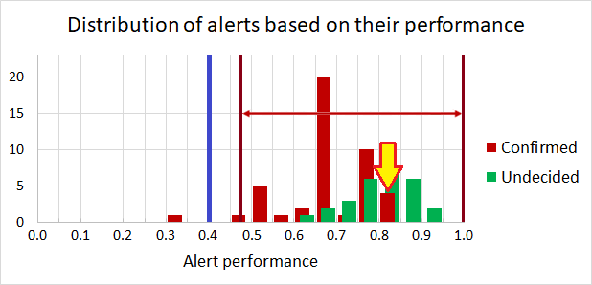

The 14 undecided alerts with two applications:
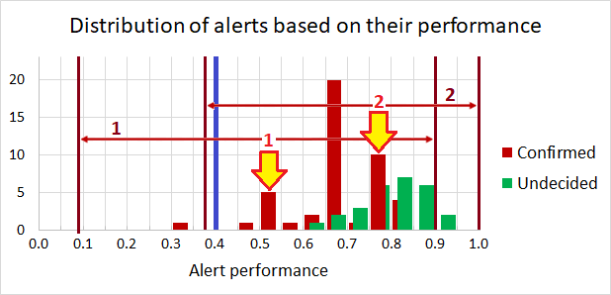
¹) 4 alerts with 1 correct and 1 incorrect application; the pointed bar contains also 1 alert with 4 applications having the same performance
²) 10 alerts with 2 correct applications

The 18 undecided alerts with one application:
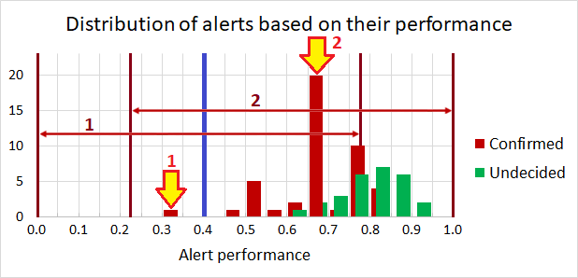
¹) 1 alert with 1 incorrect application
²) 17 alerts with 1 correct application; the pointed bar contains also 3 alert with more applications having the same performance

Model derived from the whole training set
 | Performance _{est.}¹⁾ | p-value¹⁾ | External performance²⁾ ³⁾
All predictions (accuracy) | 0.859  (0.840 ÷ 0.877) | < 10⁻¹⁰ | 0.842
Positive chemicals (sensitivity) | 0.863  (0.834 ÷ 0.891) | < 10⁻¹⁰ | 0.821
Negative chemicals (specificity) | 0.855  (0.831 ÷ 0.879) | < 10⁻¹⁰ | 0.853
¹) Confidence ranges and p-value are calculated at 95% confidence level
²) Estimated performance for training set minus GOF optimism calculated from internal validation
³) Estimation of expected performance over external sets (different from training sets)

Results from k-fold cross-validation:
 | 10-fold |  | 4-fold
 | Training sets | Test sets | Training sets | Test sets
Unique chemicals, % | 90.0  (89.9 ÷ 90.1) | 10.0  (9.9 ÷ 10.1) | 75.0  (74.9 ÷ 75.1) | 25.0  (24.9 ÷ 25.1)
Performance _{est.}, all predictions  (accuracy) | 0.859  (0.854 ÷ 0.864) | 0.844  (0.795 ÷ 0.893) | 0.858  (0.840 ÷ 0.877) | 0.843  (0.792 ÷ 0.894)
p-value, accuracy | < 10⁻¹⁰ | 2.6 x 10⁻⁹ | < 10⁻¹⁰ | < 10⁻¹⁰
Performance _{est.}, positive chemicals (sensitivity) | 0.863  (0.855 ÷ 0.870) | 0.825  (0.752 ÷ 0.897) | 0.862  (0.831 ÷ 0.894) | 0.822  (0.728 ÷ 0.916)
p-value, sensitivity | < 10⁻¹⁰ | 1.5 x 10⁻⁷ | < 10⁻¹⁰ | < 10⁻¹⁰
Performance _{est.}, negative chemicals (specificity) | 0.855  (0.848 ÷ 0.862) | 0.848  (0.790 ÷ 0.906) | 0.855  (0.840 ÷ 0.869) | 0.852  (0.808 ÷ 0.897)
p-value, specificity | < 10⁻¹⁰ | 0.00073 | < 10⁻¹⁰ | 1.4 x 10⁻⁹
¹) Confidence ranges and p-value are calculated at 95% confidence level

Results from Monte Carlo cross-validation (1,000 repetitions):
 | 75% training set |  | 63% training set
 | Training sets | Test sets | Training sets | Test sets
Unique chemicals, % | 75.0  (75.0 ÷ 75.0) | 25.0  (25.0 ÷ 25.0) | 63.0  (63.0 ÷ 63.0) | 37.0  (37.0 ÷ 37.0)
Performance _{est.}, all predictions  (accuracy) | 0.858  (0.848 ÷ 0.869) | 0.843  (0.808 ÷ 0.878) | 0.858  (0.844 ÷ 0.872) | 0.840  (0.814 ÷ 0.867)
p-value, accuracy | < 10⁻¹⁰ | < 10⁻¹⁰ | < 10⁻¹⁰ | < 10⁻¹⁰
Performance _{est.}, positive chemicals (sensitivity) | 0.862  (0.846 ÷ 0.878) | 0.822  (0.766 ÷ 0.877) | 0.862  (0.840 ÷ 0.883) | 0.816  (0.771 ÷ 0.861)
p-value, sensitivity | < 10⁻¹⁰ | < 10⁻¹⁰ | < 10⁻¹⁰ | < 10⁻¹⁰
Performance _{est.}, negative chemicals (specificity) | 0.855  (0.840 ÷ 0.869) | 0.854  (0.812 ÷ 0.896) | 0.855  (0.836 ÷ 0.874) | 0.854  (0.822 ÷ 0.887)
p-value, specificity | < 10⁻¹⁰ | 4.7 x 10⁻⁸ | < 10⁻¹⁰ | < 10⁻¹⁰
¹) Confidence ranges and p-value are calculated at 95% confidence level

Results from bootstrapping (1,000 repetitions):
 | Training sets | Test sets
Unique chemicals, % | 63.2  (61.2 ÷ 64.9) | 36.8  (35.1 ÷ 38.4)
Performance _{est.}, all predictions  (accuracy) | 0.859  (0.840 ÷ 0.877) | 0.841  (0.814 ÷ 0.867)
p-value, accuracy | < 10⁻¹⁰ | < 10⁻¹⁰
Performance _{est.}, positive chemicals (sensitivity) | 0.863  (0.835 ÷ 0.892) | 0.815  (0.769 ÷ 0.862)
p-value, sensitivity | < 10⁻¹⁰ | < 10⁻¹⁰
Performance _{est.}, negative chemicals (specificity) | 0.855  (0.830 ÷ 0.879) | 0.856  (0.824 ÷ 0.888)
p-value, specificity | < 10⁻¹⁰ | < 10⁻¹⁰
¹) Confidence ranges and p-value are calculated at 95% confidence level

Conclusions
The first evident observation from above results is that averaged estimations are practically unchangeable, no matter what kind of sampling we use for the internal validation. The variability of averaged performances is 0.01 and below even for test sets. Also the p-values are extremely low, which show very high reliability of the estimations.
The difference between performances of training and test sets - which is a measure for optimism in goodness-of-fit, - is around 0.016 for all predictions, 0.042 for positive chemicals (sensitivity) and 0.002 for negative chemicals (specificity). This difference is very low for negative chemicals, but is higher for positive chemicals and the GOF optimism should be considered.
An explanation for the latter is the fact that the training set of “Skin sensitization” model is relatively small (below 1,500 chemicals) and also is not well balanced – 60% of training chemicals are negative which favors training of negative chemicals, but is unfavorable for training positive ones.
The model displays good predictive performance for both positive chemicals (sensitivity) – 86% for training set, around 82% expected sensitivity for external sets, - and for negative chemicals (specificity) – 85% for training set, around 85% expected sensitivity for external sets, - and shows balanced prediction ability of the model.
Only 24% of alerts used in the model are confirmed at 95% confidence level, but the reasons for this are the ill-balanced training set and the small number of applications of the alerts. Indeed, 31 out of 45 undecided alerts have no incorrect applications and the other 9 have only 1 incorrect application.
Table with alerts sorted by their performance estimation:
No | Alert | Corr | Incorr | Performance _{est.}¹⁾ | p-value¹⁾
1 | 1,2-Dicarbonyls, 1,3-Dicarbonyls | 17 | 0 | 0.947  (0.847 ÷ 1.000) | 2.2 x 10⁻⁷
2 | Azlactones and unsaturated lactone derivatives | 9 | 0 | 0.909  (0.741 ÷ 1.000) | 0.00029
3 | Alkyl halides | 23 | 2 | 0.889  (0.772 ÷ 0.986) | 1.8 x 10⁻⁷
4 | Thiols and disulfide (polysulfide) compounds | 19 | 2 | 0.870  (0.735 ÷ 0.983) | 2.9 x 10⁻⁶
5 | Anhydrides (sulphur analogues of anhydrides) | 5 | 0 | 0.857  (0.607 ÷ 1.000) | 0.011
6 | Nitrosoalkenes | 5 | 0 | 0.857  (0.607 ÷ 1.000) | 0.011
7 | SN2\Ring Opening SN2 Reaction\Epoxides, Aziridines and Sulfuranes | 5 | 0 | 0.857  (0.607 ÷ 1.000) | 0.011
8 | Sulfonates | 5 | 0 | 0.857  (0.607 ÷ 1.000) | 0.011
9 | Activated (di)aryl esters | 15 | 2 | 0.842  (0.682 ÷ 0.979) | 6.9 x 10⁻⁵
10 | a,b-Unsaturated oximes | 4 | 0 | 0.833  (0.549 ÷ 1.000) | 0.026
11 | alpha,beta-Carbonyl compounds with polarized triple bond | 4 | 0 | 0.833  (0.549 ÷ 1.000) | 0.026
12 | Dithioesters | 4 | 0 | 0.833  (0.549 ÷ 1.000) | 0.026
13 | Isocyanates, Isothiocyanates | 4 | 0 | 0.833  (0.549 ÷ 1.000) | 0.026
14 | Isothiazolone derivatives | 4 | 0 | 0.833  (0.549 ÷ 1.000) | 0.026
15 | Generated free radicals | 16 | 3 | 0.810  (0.645 ÷ 0.957) | 0.00012
16 | Activated alkyl diesters | 3 | 0 | 0.800  (0.473 ÷ 1.000) | 0.066
17 | Conjugated systems with electron withdrawing groups | 3 | 0 | 0.800  (0.473 ÷ 1.000) | 0.066
18 | Lactones | 3 | 0 | 0.800  (0.473 ÷ 1.000) | 0.066
19 | N-Nitroso compounds | 3 | 0 | 0.800  (0.473 ÷ 1.000) | 0.066
20 | (Thio)Acyl and (thio)carbamoyl halides, cyanides, azides, etc. | 6 | 1 | 0.778  (0.524 ÷ 0.989) | 0.020
21 | Di-substituted a,b-unsaturated aldehydes | 6 | 1 | 0.778  (0.524 ÷ 0.989) | 0.020
22 | Activated aryl and heteroaryl compounds | 30 | 8 | 0.775  (0.646 ÷ 0.896) | 1.8 x 10⁻⁶
23 | Epoxides, Aziridines and Sulfuranes | 26 | 7 | 0.771  (0.633 ÷ 0.901) | 9.4 x 10⁻⁶
24 | alpha, beta-Carbonyl compounds with polarized double bonds | 48 | 14 | 0.766  (0.661 ÷ 0.865) | 6.0 x 10⁻⁹
25 | alpha, beta-Aldehydes | 17 | 5 | 0.750  (0.579 ÷ 0.909) | 0.00051
26 | alpha-Ketoesters | 2 | 0 | 0.750  (0.368 ÷ 1.000) | 0.162
27 | Benzoyl phosphine oxides | 2 | 0 | 0.750  (0.368 ÷ 1.000) | 0.162
28 | Benzyl or phenethyl salicylates | 2 | 0 | 0.750  (0.368 ÷ 1.000) | 0.162
29 | Diacyl peroxides, anhydrides (sulphur analogues of diacyl peroxides) | 2 | 0 | 0.750  (0.368 ÷ 1.000) | 0.162
30 | Phenyl carbonates | 2 | 0 | 0.750  (0.368 ÷ 1.000) | 0.162
31 | Polarised alkene - alkenyl pyridines, pyrazines, pyrimidines or triazines | 2 | 0 | 0.750  (0.368 ÷ 1.000) | 0.162
32 | Sulfates | 2 | 0 | 0.750  (0.368 ÷ 1.000) | 0.162
33 | Sulphonyl halides or cyanides | 2 | 0 | 0.750  (0.368 ÷ 1.000) | 0.162
34 | Thiocyanates | 2 | 0 | 0.750  (0.368 ÷ 1.000) | 0.162
35 | Thiourea compounds | 2 | 0 | 0.750  (0.368 ÷ 1.000) | 0.162
36 | Quinone(s)/imines, Quinone methide(s)/imines, Quinoide oxime structure, Nitroquinones, Naphtoquinone(s)/imines | 84 | 29 | 0.739  (0.658 ÷ 0.817) | < 10⁻¹⁰
37 | Ketones | 10 | 3 | 0.733  (0.517 ÷ 0.932) | 0.0085
38 | alpha-Activated haloalkanes | 9 | 3 | 0.714  (0.486 ÷ 0.926) | 0.016
39 | alpha-Activated benzyls | 4 | 1 | 0.714  (0.409 ÷ 0.982) | 0.090
40 | Aldehydes | 60 | 26 | 0.693  (0.597 ÷ 0.787) | 7.3 x 10⁻⁸
41 | Amides | 9 | 4 | 0.667  (0.436 ÷ 0.885) | 0.034
42 | Bis Aldehydes | 7 | 3 | 0.667  (0.412 ÷ 0.907) | 0.057
43 | Bifunctional alpha, beta-carbonyl containing compounds | 5 | 2 | 0.667  (0.379 ÷ 0.935) | 0.099
44 | Active cyclic agents | 3 | 1 | 0.667  (0.330 ÷ 0.974) | 0.183
45 | Activated (thio)esters | 1 | 0 | 0.667  (0.224 ÷ 1.000) | 0.403
46 | Allyl and propargyl sulfate and sulphonate esters | 1 | 0 | 0.667  (0.224 ÷ 1.000) | 0.403
47 | Azomethynes with a sulfo leaving group | 1 | 0 | 0.667  (0.224 ÷ 1.000) | 0.403
48 | Carbenium ion | 1 | 0 | 0.667  (0.224 ÷ 1.000) | 0.403
49 | Carbodiimides | 1 | 0 | 0.667  (0.224 ÷ 1.000) | 0.403
50 | Dithiocarbamates | 1 | 0 | 0.667  (0.224 ÷ 1.000) | 0.403
51 | Guanidines | 1 | 0 | 0.667  (0.224 ÷ 1.000) | 0.403
52 | Hydrolysis\Glucoside hydrolysis | 1 | 0 | 0.667  (0.224 ÷ 1.000) | 0.403
53 | Iodoalkynes | 1 | 0 | 0.667  (0.224 ÷ 1.000) | 0.403
54 | Isothiazolidin-3-ones (sulphur) and Isothiazolone derivatives | 1 | 0 | 0.667  (0.224 ÷ 1.000) | 0.403
55 | Michael Addition\Michael Addition on Conjugated Systems with Electron Withdrawing Group\alpha, beta-Carbonyl Compounds with Polarized Double Bonds - Methacrylate type | 1 | 0 | 0.667  (0.224 ÷ 1.000) | 0.403
56 | N-Haloacylamides | 1 | 0 | 0.667  (0.224 ÷ 1.000) | 0.403
57 | N-Sulfonylazomethynes | 1 | 0 | 0.667  (0.224 ÷ 1.000) | 0.403
58 | Polarised Alkenes- sulfones | 1 | 0 | 0.667  (0.224 ÷ 1.000) | 0.403
59 | Pyrazolones and pyrazolidinones | 1 | 0 | 0.667  (0.224 ÷ 1.000) | 0.403
60 | Radical Reactions\Free Radical Formation\Hydroperoxides | 1 | 0 | 0.667  (0.224 ÷ 1.000) | 0.403
61 | SNAr\Nucleophilic Aromatic Substitution on Activated Halogen, Cyano,Isocyano, Sulfo, Sulfonyl Groups, etc.\Iodopyrazole | 1 | 0 | 0.667  (0.224 ÷ 1.000) | 0.403
62 | Hydroperoxides | 36 | 19 | 0.649  (0.526 ÷ 0.770) | 0.00019
63 | (Thio)Phosphates | 2 | 1 | 0.600  (0.228 ÷ 0.956) | 0.356
64 | C-Nitroso compounds | 2 | 1 | 0.600  (0.228 ÷ 0.956) | 0.356
65 | Activated alkyl esters and thioesters | 4 | 3 | 0.556  (0.254 ÷ 0.851) | 0.295
66 | Carbamates | 2 | 2 | 0.500  (0.147 ÷ 0.853) | 0.529
67 | Acylation\Ester Aminolysis or Thiolysis\Benzyl or Phenethyl Salicylates | 1 | 1 | 0.500  (0.094 ÷ 0.906) | 0.643
68 | beta-Lactams | 1 | 1 | 0.500  (0.094 ÷ 0.906) | 0.643
69 | Cyanoalkenes | 1 | 1 | 0.500  (0.094 ÷ 0.906) | 0.643
70 | Vinyl-type compounds with electron-withdrawing groups | 1 | 1 | 0.500  (0.094 ÷ 0.906) | 0.643
71 | Aromatic carbonyl compounds | 6 | 7 | 0.467  (0.227 ÷ 0.708) | 0.434
72 | Pyranones, Pyridones (and related nitrogen chemicals) | 0 | 1 | 0.333  (0.000 ÷ 0.776) | 1.000
¹) Confidence ranges and p-value are calculated at 95% confidence level

